SPARK: Simple Play Adaptations to Reference for Kids

Hand2Mind Express Your Feelings Sensory Bottles
Description: | Image:
Express Your Feelings Sensory Bottles are designed to help children identify and manage their feelings in a quiet, hands-on way. Each bottle has a unique facial expression, color, and interactive element that corresponds to one of four emotions: happy, angry, scared, and sad. | 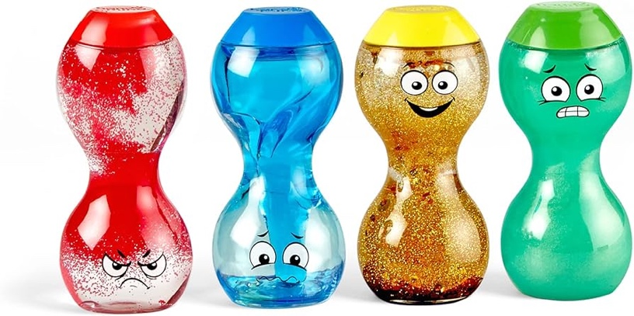  Purchasing Information  Demo Video  Activity Guides

Who Might Benefit?
Those who…
• Are learning to identify their own feelings.
• Are struggling with socially appropriate reactions to strong feelings.
• Are learning or need support with self-regulation.
• Need quiet, self-directed activities throughout the day to regroup.
• May need to touch or fidget in order to focus.

Why Use?
Provides an opportunity to…
• Express feelings of happy, angry, scared, and sad.
• Explore opportunities for self-regulation.
• Engage in quiet exploration and self-calming activities.
Instructions for Use: | Adaptation Ideas:
Environmental Considerations  - Some children might do better with a one-on-one discussion of feelings rather than in a whole group setting.  - A quiet, more private area of the classroom could be considered for a child who has difficulty talking about or controlling their feelings.  Positioning  - Explore in just about any position where the bottles can be reached or viewed.  Basic Play/Use  - Shake, tip, or swirl the bottles and watch the contents move and settle.  Extended Play/Use  - Play color identification activities.  - Explore and use in conjunction with a light box.  Play/Use with Others  - Play/sing the song “If You’re Happy and You Know It” and make up actions to go along with the feelings.  - Take turns drawing cards with color or color words printed on them, then selecting the corresponding bottle and flipping it. When the bottle contents settle, the next child takes a turn. | Optional Additional Materials/Supplies  - Dycem or shelf liner.  Build It Up  - Use Dycem or shelf liner around middle of the bottle to build up gripping surface or provide additional tactile cues.  Stabilize It  - Use shallow box or cylindrical holder with children who have difficulty holding or setting bottles upright to view action.  Simplify It  - Introduce one bottle at a time.  - Reduce the number of emotions discussed.  Contain It  Use shallow box to contain bottles so they don’t scatter during vigorous exploration.  Add Sensory Cues  - Use with Light Box.  - Listen to quiet music while demonstrating, exploring bottles.  Communication Support  - Add visual supports (non-transient cues), such as communication cards, for the child to communicate how they are feeling.  - Read stories about different characters and their feelings.  Alternative Uses  - Use as simple timers (e.g. "When colored bubbles settle, it's time to…").  - As a whole group activity, graph children's color preferences, or how specific colors make them feel.  - Use viewing bottles as a whole group transition activity, or to settle prior to story or circle time.  DIY Alternatives  - How to make a sensory bottle video.  - DIY Light Box video.

Additional Considerations:

Bottles and their actions may be distracting at first

Explain to children that everyone needs different things to help them learn

It may be necessary to develop rules for use of sensory bottles as “tools, not toys” (ex. No throwing).

Resources:

See Social Narratives from OCALI’s Autism Center Grab and Go Resource Gallery of Interventions

For further information, visit the Social Narratives Autism Internet Module

Like Social Stories, Power Cards teach and reinforce academic, behavioral, organizational, and social skills. Power Cards are visual supports that include an individual’s special interest. See Power Cards from OCALI’s Autism Center Grab and Go Resource Gallery of Interventions

Reminder Cue Cards from OCALI’s Autism Center Grab and Go Resource Gallery of Interventions help teach and remind individuals how to engage in positive behaviors. Reminder Cue Cards provide “what to do” suggestions when an individual is feeling anxious, stressed, or confused. They also support interactions with peers, and offer ways to self-regulate, and manage emotions.

Practical Strategies for Teachers/Caregivers: Teaching Social Emotional Skills from the Center on the Social Emotional Foundations for Early Learning

Ohio Early Learning Standards:
- SE: Self Awareness: Develops an understanding of emotions (1.b.).
- SE: Self Awareness: Begins to manage emotions and actions (2.a.).
- SE: Social Awareness: Develops empathy toward and understanding of others (3 a.).
- SE: Relationship Skills: Develops ability to use simple strategies to resolve conflicts with peers (4.c.).

Words to Encourage Play/Use
I feel  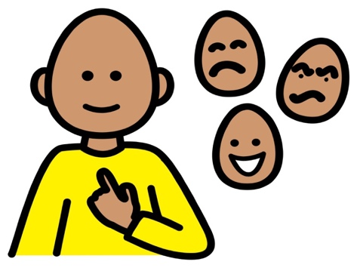 | Happy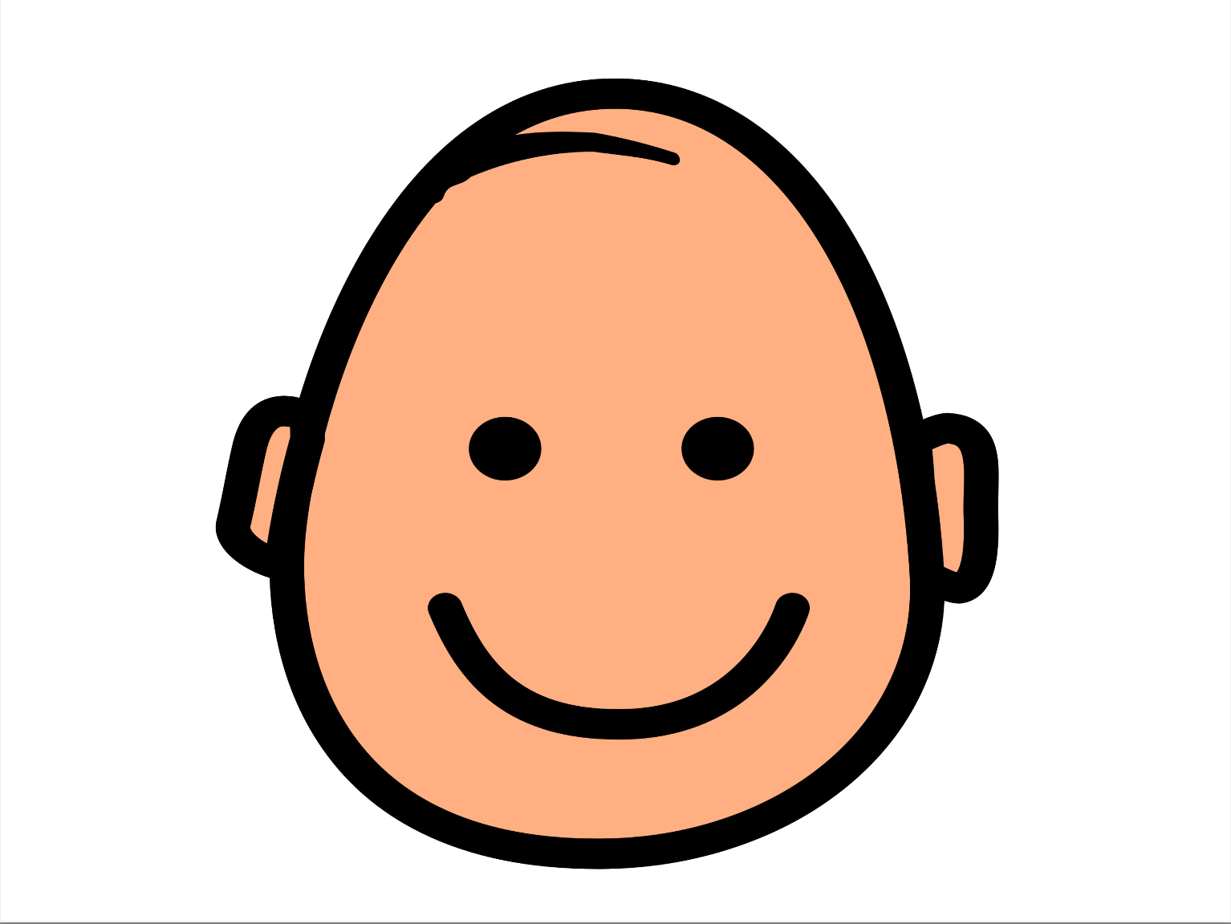 | Sad
Sick | Surprised | Tired 
Confused | Mad | Scared  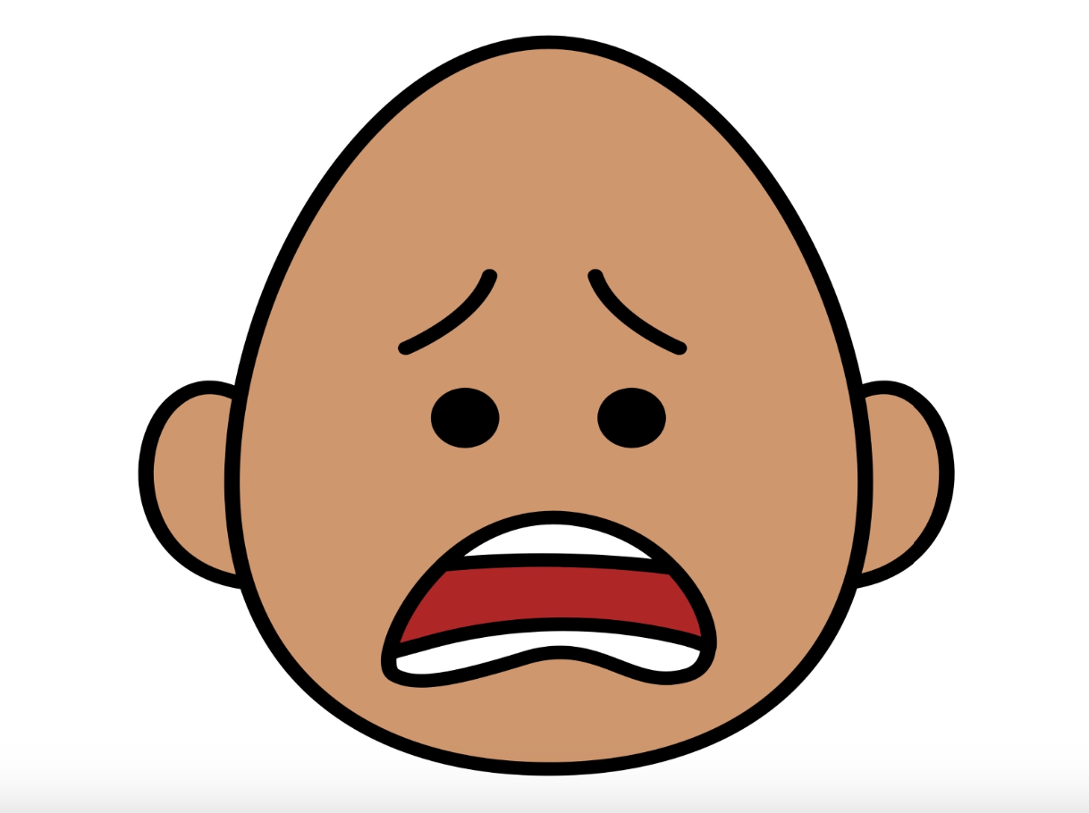
*”Adaptations” adapted from: Haugen’s Modes for Adapting Toys based on materials from the "Let's Play" Project at the University of Buffalo
PCS is a trademark of Tobii Dynavox, LLC. All rights reserved. Used with permission.

